To: North Carolina Department of Environmental Quality, Division of Air Quality

Attn: Michael Abraczinskas

Date: November 13, 2024

RE: Comments from Undersigned Environmental Organizations Opposing the Permit Modification for the Roxboro Steam Electric Plant

Thank you for the opportunity to provide feedback on the modification of the air emissions permit for the Roxboro Steam Electric Plant, one of the largest online coal plants in the United States. While we acknowledge the urgent need to transition our electric grid away from coal, the undersigned organizations strongly believe there are more cost effective, environmentally beneficial methods of site modification than transitioning the Roxboro site to methane gas combustion. Because of the recently finalized rules under Section 111 of the Clean Air Act, the cost competitiveness of renewable energy resources, the potential for cumulative pollution impacts associated with Duke Energy’s proposed gas buildout, and the likelihood of excess costs to ratepayers, we strongly oppose this permit modification.

**Failure of the Roxboro Steam Plant to Align with House Bill 951**

According to House Bill 951 (2021), it is crucial for all entities of the State to prioritize North Carolina’s transition to clean energy generation. Our state carbon plan requires reduction of carbon dioxide emissions by 70% relative to 2005 levels by 2030 and to attain carbon neutrality by 2050. A large component of the Carbon Plan focuses on the retirement of coal, which contributes around 8,400 MW of power to North Carolina’s electric grid annually. However, methane gas is not a clean energy source to replace coal and is a false solution to the bipartisan problem of greenhouse gas emissions causing climate change. Building this gas plant will delay interim decarbonization goals to 2035 at the earliest, imperling the state’s clean energy transition.

As the Division of Air Quality is well aware, transitioning from coal to methane combustion changes the amount and chemical composition of carbon emitted to the atmosphere. [1]There is well documented evidence that methane is a more potent greenhouse gas than carbon dioxide due to its chemical structure and potential to trap heat. Furthermore, methane can react with oxygen to produce carbon dioxide, effectively negating the claim that methane remains in the atmosphere for less time than carbon dioxide. According to scientists at MIT, “the more concerned we are about global warming over the next 10 or 20 years, the more emphasis we have to put on cutting methane emissions.”[2] Over a 100 year period, any amount of methane would trap about 28 times as much heat as an identical ton of CO2. This scientific reality does not begin to consider other related emissions from a methane gas plant, including NOx, SOx, carbon monoxide, and particulate matter (PM 2.5, PM 10, and others). As experts in air quality, DAQ understands how these criteria air pollutants need strong enforcement, as they are already subject to stringent permitting and reporting requirements. While the Roxboro plant will no longer be operating as a coal plant, the site has historically been petitioned for non-attainment of NAAQS under the Clean Air Act. In 2016, the EPA granted a Sierra Club petition requesting that the EPA reject the Title V permit due to noncompliance of CAA § 505(b)(2), 42 U.S.C. § 7661d(b)(2); 40 C.F.R. § 70.8(c)(l).[3] As the EPA becomes more stringent over the long term, imposing stronger rules for point source pollution, the DEQ will waste valuable time and resources monitoring this site.

Unfortunately, the draft permit does not include effective monitoring measures for certain harmful pollutants, including the NAAQS. As discussed below, failure to effectively monitor and control these pollutants can lead to a higher risk of skin, lung, and bladder cancer, breathing problems, and respiratory tract irritation.[4]

Permitting this facility would cement North Carolina’s power sector into a further reliance on fossil fuels for the next two decades at minimum. The plans to transition from methane to green hydrogen are unproven at this scale and uncertain at this time according to Duke Energy.[5] This directly endangers our state’s legal commitment to carbon neutrality and fails to align with the requirements issued by the North Carolina General Assembly. The NC DAQ must deny this permit to avoid violation of our state’s laws.

**Failure of Methane Plants to Comply with the Clean Air Act, including Section 111**

The Clean Air Act, 42 USC Sec. 7475 instructs that no major emitting facility can be constructed without a permit. To receive a permit, the owner or operator of the proposed facility must demonstrate that “emissions from construction or operation of such facility will not cause, or contribute to, air pollution in excess of any (A) maximum allowable increase or maximum allowable concentration for any pollutant in any area to which this part applies more than one time per year, (B) national ambient air quality standards (“NAAQS”) in any air quality control region, or (C) any other applicable emissions standard or standard of performance under.”[6] Additionally, the added criteria pollutants must not contribute to significant deterioration of the air quality in the region, even if that deterioration does not violate the NAAQS, and they must use the Best Available Control Technology (“BACT”).

Using its SIP, North Carolina has met the NAAQS for each criteria pollutant since 2015.[7] The applicable air quality standards for criteria pollutants are as follows[8]:

| **NAAQS for Criteria Pollutants** | |
| --- | --- |
| Ozone | 0.070 Parts per million (ppm) 8-hour average |
| Lead | 0.15 micrograms per cubic meter (μg/m3) 3-month average |
| Particulate Matter 2.5 (PM 2.5) | 12.0 μg/m3 1-year average |
| 15.0 μg/m3 1-year average |
| 35 μg/m3 24-hour average |
| Particulate Matter 10 (PM 10) | 150 μg/m3 24-hour average |
| Carbon Monoxide | 9 ppm 8-hour average |
| 35 ppm 1-hour average |
| Nitrogen Dioxide | 100 ppb 1-hour standard |
| 53 ppb 1-year average |
| Sulfur Dioxide | 75 ppb 1-hour average |
| 0.5 ppm 3-hour average |

For AQCR that are in attainment or unclassifiable, stationary sources, including natural gas plants, are subject to the CAA’s provisions relating to PSD. PSD standards are created to prevent significant deterioration of air quality in areas that already have clean air while still allowing some industrial growth. The PSD standards require (1) a new stationary source to use the Best Available Control Technology (“BACT”), (2) an air quality analysis, (3) an additional impact analysis, and (4) opportunity for public involvement.[9] While NAAQS apply the same way to each state, PSD increments vary by area.

AQCR are classified into one of three classes in North Carolina. Class I is the most stringent standard, for the areas with the cleanest air. “PSD regulations require a single-source impact analysis be conducted for all new major sources … with the potential for air quality impacts on a Class I area.”[10] All new sources within 300 km of a Class I source must do an analysis of the impacts on that Class I area.[11] The Class I areas within 300 km of Roxboro and Marshall, for which Duke Energy must complete a single-source impact analysis, are listed below. Distances were approximated using google maps.

| **Class I Area** | **Approx. Distance from Roxboro** | **Approx. Distance from Marshall** |
| --- | --- | --- |
| Linville Gorge National Wilderness Area | 267.05 km | 74.20 km |
| Great Smoky Mountains National Park | 400.31 km | 81.22 km |
| Joyce Kilmer Slickrock National Wilderness Area | 465.38 km | 122.54 km |
| Shining Rock National Wilderness Area | 228.70 km | 50.27 km |
| Swanquarter National Wildlife Refuge | 271.62 km | 575.55 km |
| Cape Romain National Wildlife Refuge (N/A) | 373.17 km | 428.64 km |
| James River Face Wilderness Area | 139.38 | 347.18 |
| Cohutta Wilderness Area | 531.12 | 206.03 |

In order to get a permit, the natural gas plant must not contribute more than the maximum allowed increase in ambient pollutant concentrations allowed over baseline concentrations.[12] Those concentrations are listed in the table below:

| **Class I Area Increments (in micrograms per cubic meter, AKA μg/m3)** | | |
| --- | --- | --- |
| SO2 | 3-hour | 25 |
| 24-hour | 5 |
| Annual | 2 |
| PM10 | 24-hour | 8 |
| Annual | 4 |
| PM2.5 | 24-hour | 2 |
| Annual | 1 |
| NO2 | Annual | 2.5 |

**CLASS II PSD INCREMENTS**

The Class II PSD increments apply to a majority of North Carolina. Those increments appear in the table below.[13]

| **Class II Area Increments (in micrograms per cubic meter, AKA μg/m3)** | | |
| --- | --- | --- |
| SO2 | 3-hour | 512 |
| 24-hour | 91 |
| Annual | 20 |
| PM10 | 24-hour | 30 |
| Annual | 17 |
| PM2.5 | 24-hour | 9 |
| Annual | 4 |
| NO2 | Annual | 25 |

Before EPA can grant a permit to Duke Energy for a proposed natural gas plant, the utility must:

1. Prove that the new plant will not violate the NAAQS.
2. Complete a Class I increment analysis for every Class I within 300 km of the proposed plant. In order to qualify for a permit, the projections from the analysis must show that the plant will not exceed the PSD increments for any of the Class I areas within 300 km of the proposed plant. (See the Class I area table above for approximate distance between Class I areas and each proposed plant). It is not evident that Duke Energy has completed these analyses yet.
3. Complete a single source impact analysis for both plants to evaluate the potential significant increase in emissions. If the single source analysis demonstrates that a pollutant or multiple pollutants exceeds the SILs, then Duke Energy must complete a cumulative impact air quality analysis.[14]

Further, there are new guiding rules for power plant emissions at the federal level. As the Division is well aware, federal rules supersede any state or local interests in the development of fossil fuel infrastructure. In April 2024, the Biden administration finalized new rules governing the emissions limits for coal and gas power plants in accordance with the need to decarbonize the American electric grid. Under these rules, plants operating more than 40% of the time in a given calendar year must meet strict carbon pollution limits.[15] Many of these plants must also install carbon capture and sequestration mechanisms or alter plant operations to use green hydrogen. This poses significant issues for Duke Energy’s gas buildout, as many of their assets will be forced to run lower amounts of time and overall produce fewer MW of power. Duke filed its initial Carbon Plan and applications for their first two gas plants in August 2023 and January 2024, and these rules were not finalized at the time. DAQ should consider the impact of a world in which these rules are maintained and the associated levels of enforcement.

Duke Energy has been aware of the existence of these rules since their issuance as drafts. Duke Energy filed comments in opposition to these rules at the federal level in 2023 and is currently suing to stop these rules.[16] Limits on emissions for fossil fuel infrastructure will directly endanger Duke’s proposed plans to generate profits for their shareholders. Despite the opposition of major utility companies, these rules may stand without significant substantive modifications. Within the past few weeks, the U.S. Supreme Court opted not to issue a preliminary injunction on these rules.[17] This means that Duke Energy must reduce the plant’s operating capacity in order to meet these requirements or face massive fines. Even if this reduction occurs or the plant is converted to hydrogen, costs on North Carolina ratepayers will drastically increase past already projected high bills.[18]

Unfortunately, Duke Energy has failed to provide sufficient data regarding its future compliance with these rules, and the DEQ has failed to include any enforceable permit limitations to the rules’ implementation. DEQ must include a carbon dioxide limit with a 2032 effective date, as well as an enforceable coal retirement date before 2032 to ensure timely compliance, but it has so far failed to do so. If this plant is approved and built in 2029, Duke Energy will be able to run it for four years (until 2032) before it will have to convert to hydrogen, employ carbon sequestration technology (which North Carolina’s geography is not suited for), or run the plants more inefficiently at lower capacity. If the new methane gas plant operates for 80% of the year, which Duke Energy anticipates it will before it is required to comply, it will emit more than twice the total carbon pollution the Roxboro 1 and 4 coal units produced in 2023.[19] All of these scenarios saddle ratepayers with unnecessary costs for an asset that will be more intensely regulated in just four short years post-build out. The current CRIPRP order confirms that under these rules, the selected portfolio will: “increase carbon dioxide emissions by more than four million tons in the year 2035, likely delaying achievement of the Interim Target to 2036 or later and increasing total system costs by more than $600 million."[20] Ultimately, Duke Energy and DEQ’s lack of consideration for the Clean Act rules and their impact is a violation of the “least cost” approach to carbon reduction. This polluting plant will be inefficient and a high cost for ratepayers.

**Failure to Mitigate Significant Risks to Duke Energy Ratepayers**

While the undersigned organizations acknowledge the Division of Air Quality has little to no control over the amount Duke Energy customers are paying for their monthly electric bills, it is undeniable that a permit for the Roxboro gas facility would enable Duke to reap massive profits from their ratepayers in North Carolina. According to DAQ’s mission statement, the Division is tasked to “[work] with the state's residents to protect and improve outdoor, or ambient, air quality in North Carolina for the health, benefit and economic well-being of all.” DAQ’s consideration of the economic well-being of all residents within the state must include the economic and environmental burdens proposed for Duke Energy ratepayers, as Duke Energy retains control over much of our state’s utility landscape. As the promoter of health and economic benefit, DAQ should be concerned both about rising bills and the collective cost of pollution.

More than 30% of Duke Energy’s customers need some kind of bill assistance, and they are incredibly sensitive to rate increases and bill changes.[21] Already, 1.5 million North Carolinians are energy-burdened, meaning they spend more than 6% of their household income on energy bills.[22] However, **a majority of the fluctuations and increases in monthly utility bills stem from methane gas pricing volatility.** According to a study completed by EQ Research, increases in fuel costs account for 68% of residential bill rates from 2017 to 2024 for Duke Energy Carolina Customers and 46% of residential rates in the same time period for Duke Energy Progress customers.[23] Residents are already suffering with bill increases, and allowing the construction of the Roxboro gas plant via a successful air permit will cement these same customers into even higher bills. This is already evident in the publicly available filings. By 2033, Duke Energy Progress customers would pay 39% more over previous estimates; Duke Energy Carolinas would pay 73% more per month by Duke Energy’s own estimate.[24]

In addition to these rising bills, customers must all bear the cost of air pollution in other ways, namely in disability adjusted life years (DALYs) and lost productivity. DALYs are the equivalent of one economic year lost to disease. According to the National Institutes of Health, the cost of global air pollution in DALYs is estimated to be in the range of $1.1–$2.9 trillion annually.[25] DALYs reflect the multi-faceted impacts from methane pollution, including acute and chronic respiratory illness such as lung infections, disease, and asthma. In 2019, asthma accounted for 21.6 million DALYs, and in 2021, chronic obstructive pulmonary disease, lower respiratory infections, and trachea, bronchus, and lung cancers led the top half of global diseases causing death.[26]

Person County has a high social vulnerability index of 0.95 out of 1, or is a community that will most likely need support before, during, and after a hazardous event due to high rates of unemployment, racial and ethnic minority status, and disability status.[27] Additional pollution sources on top of this marginalized status imperils residents. Communities surrounding the Roxboro plant already have a disproportionately high prevalence of asthma. ndeed, over 10% of the county population suffers from a chronic health condition caused and exacerbated by high rates of PM 2.5, O3, NO2, SO2, CO, and CH4. [28] This is in addition to high population levels of COPD, lung cancer, and all other cancers. This puts communities around the Roxboro plant at higher risk for compounding health vulnerabilities, leading to greater susceptibility to chronic pollution-associated illness.[29]

Figure 1: NC Environmental Justice Hub, Roxboro Plant percentage of county adult population with asthma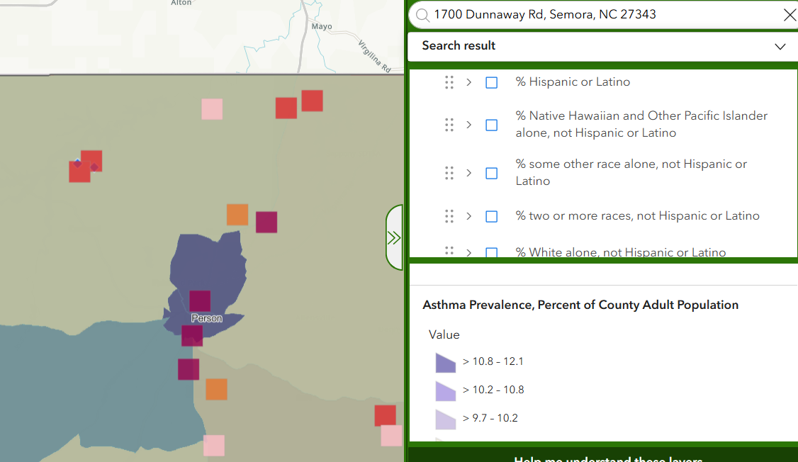

It is clear that the approval of this air permit would cement North Carolinians across the state into financial responsibility for Duke Energy’s investments in fossil fuel infrastructure. However, this presents extreme financial risks for the well-being of our state, as coal and gas plants both pose risks of becoming stranded assets. Globally, coal and gas plants could result in over $1 trillion of lost profits for the oil and gas industry.[30] Usually, these stranded asset risks fall on wealthy stakeholders and their subsequent portfolios. However, Duke Energy was granted a guaranteed rate of return of 10% on their energy generation projects from the North Carolina Utilities Commission.[31] This means that stakeholders are guaranteed to profit off of the eventual failure of this infrastructure to generate revenue, further increasing bills of regular ratepayers to cover Duke Energy’s losses.

While the Division of Air Quality cannot control the markets or rates of return on fossil fuel projects, we believe that the Division does have a responsibility to heavily weigh future financial risks to the citizens of North Carolina. Granting a permit modification for the Roxboro facility to convert to methane gas exposes residents to bill increases of over $80 per month over the next 15 years.[32] Based on the available financial information regarding the buildout of methane gas, the Division cannot in good faith modify this permit at the expense of North Carolinians.

**Failure of the Applicant to Maximize Inflation Reduction Act Funding to Lower Cost Burden**

Despite potential for repeal under a Trump administration, the Inflation Reduction Act (IRA) funding still exists and has been critically overlooked by both the Commission and Duke Energy. DAQ should consider denying the permit for the failures to use IRA funding to reduce air pollution within these proposed gas plant plans. Duke Energy has failed to incorporate IRA funding into its current portfolios, a major missed opportunity to lower carbon emissions at lower cost to ratepayers. The DAQ should eschew this permit modification in light of grave underestimates of these clean energy cost savings.

The IRA, the most robust climate legislation in U.S. history, aims to close two-thirds of the carbon emissions gap between the nation’s climate goals and existing climate policies. Of the $740 billion in spending, $369 billion is allocated to loans, grants, and tax provisions for clean energy jobs, infrastructure, vehicles, and buildings. This is intended to reduce carbon emissions 40 percent by 2030. The IRA also has specific provisions for historically disadvantaged and low-wealth communities, including $3 billion in community-led block grants, $3 billion for equitable transportation program development, $27 billion for the Greenhouse Gas Reduction Fund (60 percent of which must be allocated to low-resourced communities), and more. There are additional provisions for “adders” or financial bonuses for clean energy projects in “legacy energy communities” — communities historically harmed by oil and gas pollution — and/or low-wealth communities. For example, there is a 10 percent bonus for the Investment Tax Credit and Production Tax Credit for legacy energy communities to transition to renewable energy sources.

Unfortunately, the Commission has fallen behind in incorporating IRA funding into its Carbon Plan/Integrated Resource Plan, leading to more of the “status quo” inclusion of fossil fuel infrastructure. This is, in part, due to the Commission’s lack of regulatory oversight of Duke Energy. The Commission has failed to scrutinize the Company’s carbon plan, allowing the Company to decide the fate of the state’s carbon reduction goals in disservice to the Commission’s stated goal of “encourag[ing] and promot[ing] harmony between public utilities, their users and the environment.”[33]

To combat the high level of proposed methane gas use, the North Carolina Utilities Commission Public Staff also recommended that Duke Energy “should seek to maximize the benefits of the Energy Infrastructure Reinvestment (EIR) loan program,” which provides projects with low-cost loans for energy infrastructure related to electricity generation or transmission, replacing old energy infrastructure with low-emissions infrastructure, and otherwise supporting the revitalization of energy communities. The Staff further noted that “aggressively seeking EIR funds could lead to increased renewable and storage deployment and could save ratepayers more than $400 million through 2032.”[34] Expert witness Edward Burgess, an engineer who testified on behalf of the Attorney General’s office, supported the Public Staff filings, adding that the EIR program could be used to cover transmission upgrades needed for more solar and battery storage projects. An additional benefit to the EIR is that the program specifically supports energy communities — communities disproportionately affected by oil and gas, and by fossil fuel infrastructure generally. Under the current CPIRP, Duke Energy is compelled to “study” the EIR. While a start, this ultimately is not a significant enough mandate to fully embrace IRA funding. The DAQ should consider this lack of inclusion of IRA funding in decision-making.

**Failure to Measure Effects of Pollution of Neighboring States**

1. Duke Energy must provide all the relevant pollution data, especially pollution from neighboring states.

On March 15, 2023, the EPA finalized the [Good Neighbor Plan Rule](https://www.epa.gov/csapr/good-neighbor-plan-2015-ozone-naaqs), which implements NOx limits on power plants and industrial sources in 23 states. The Clean Air Act (CAA)’s Good Neighbor Provision mandates upwind states to formulate state implementation plans (SIPs) to prohibit emissions that will “significantly contribute to nonattainment of a NAAQS, or interfere with maintenance of a NAAQS, in a downwind state.”[35] In the context of air pollution, upwind typically means the area or location where the pollution originates from, and downwind refers to which the wind carries the pollutant toward a neighboring state.

The Duke Energy Roxboro Plant is located in Semora, North Carolina, near the North Carolina-Virginia border. Approximately 33 miles north of Roxboro, there is a Dominion Energy Clover Power Station in Halifax County, Virginia.

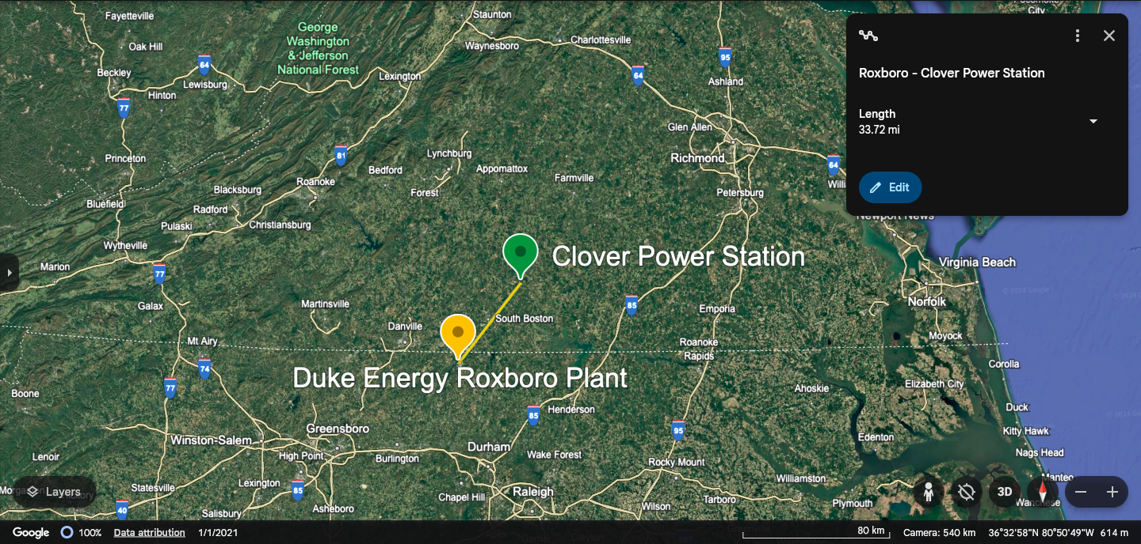

Source: [Google Earth](https://earth.google.com/web/data=MikKJwolCiExVXVrTDB1TkZwRE11SVpjVFg3WUpJcmFMSjVKdmxza1ESAA)

Virginia, the upwind state, should comply with the SIP requirements under the Good Neighbor Plan Rule to prevent emissions that would contribute to more air pollution in North Carolina, the downwind state. The air permit does not indicate that Duke Energy looked into the Clover Power Station in Virginia. This raises environmental concerns due to emissions potentially impacting communities across the state lines. Furthermore, when it comes to the proximity of North Carolina and Virginia, prevailing winds tend to be from the west or northwest, which can carry air pollutants eastward into communities in Virginia, especially during the winter months when northwestern winds are more common.[36] This data should have been analyzed to make sure North Carolina is not furthering pollution in Virginia communities.

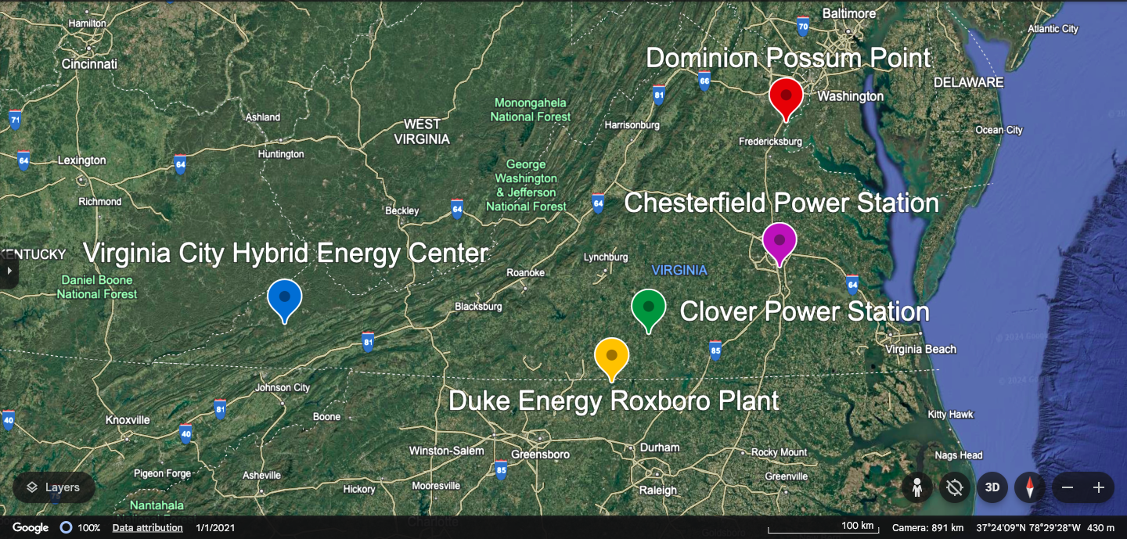

Source: [Google Earth](https://earth.google.com/web/data=MikKJwolCiExVXVrTDB1TkZwRE11SVpjVFg3WUpJcmFMSjVKdmxza1ESAA)

In addition, the EPA’s Cross-State Air Pollution Rule (CSAPR) requires North Carolina to reduce annual emissions of sulfur dioxide (SO₂) and nitrogen oxides (NOₓ) to meet the 1997 standards for fine particulate matter (PM₂.₅), and to reduce annual SO₂ and NOₓ emissions to comply with the 2006 24-hour standard for PM₂.₅.[37] Also, North Carolina is among the SO₂ Group 1 states, meaning the EPA identifies North Carolina to be a significant contributor of SO₂ to downwind states. Therefore, it is imperative that Duke Energy provides all relevant data such as wind patterns and pollution sites from nearby states.

1. Failure to measure the effects of air pollution in neighboring states can have significant implications for public health.

Unfortunately, air pollution does not respect state boundaries, so pollutants like particulate matter (PM), nitrogen oxides (NOx), sulfur dioxide (SO₂), and volatile organic compounds (VOCs) can travel long distances, affecting air quality far beyond the intended area.

Not measuring the air quality impacts of other states poses a risk to public health in neighboring states because there is an underestimation of the pollution scope. Duke Energy’s analysis indicates that its methane gas plant will generate higher levels of dangerous volatile organic compounds and carbon monoxide than the existing coal plant. This is extremely concerning for many reasons. VOCs can cause liver, kidney, and nervous system damage, while even low to moderate levels of carbon monoxide can cause chest pain or angina, impaired vision, and reduced brain function. Additionally, the short-term effects of nitrogen oxides (NOx) can irritate the eyes, nose, throat, and lungs, causing coughing, shortness of breath, tiredness, and nausea. Long-term exposure to NOx can cause chronic lung disease and may affect the senses. Children, asthmatics, and adults with heart and respiratory disorders are most sensitive to NOx. The air permitting process must not only consider the impact of emissions on vulnerable populations; but also account for pollution from neighboring states so important health impacts are not missed.

Finally, Duke Energy has failed to provide sufficient data regarding its future compliance with recent EPA rules on harmful carbon pollution from new methane gas plants (Clean Air Act rule) that will limit this proposed methane gas plant’s operation starting in 2032. In a world that is constantly changing, there must be a full assessment of how emissions will impact communities and vulnerable populations, even if it is across borders. A failure to address the cumulative impact of multiple sources of pollution disregards the health of the community that surrounds the plant and others.

**Failure to Mitigate Cumulative Impacts on Local Residents**

In its 2023/2024 Carbon Plan, Duke Energy proposed a clean energy transition that included one of the largest gas build outs in the United States. From multiple new and converted gas plants to supporting pipeline and storage infrastructure, Duke Energy does not have clear goals for a clean, affordable energy transition. However, it is not Duke that will suffer from the cumulative impacts of pollution their infrastructure will generate, but rather the residents of the communities in close proximity to gas plants and pipelines.

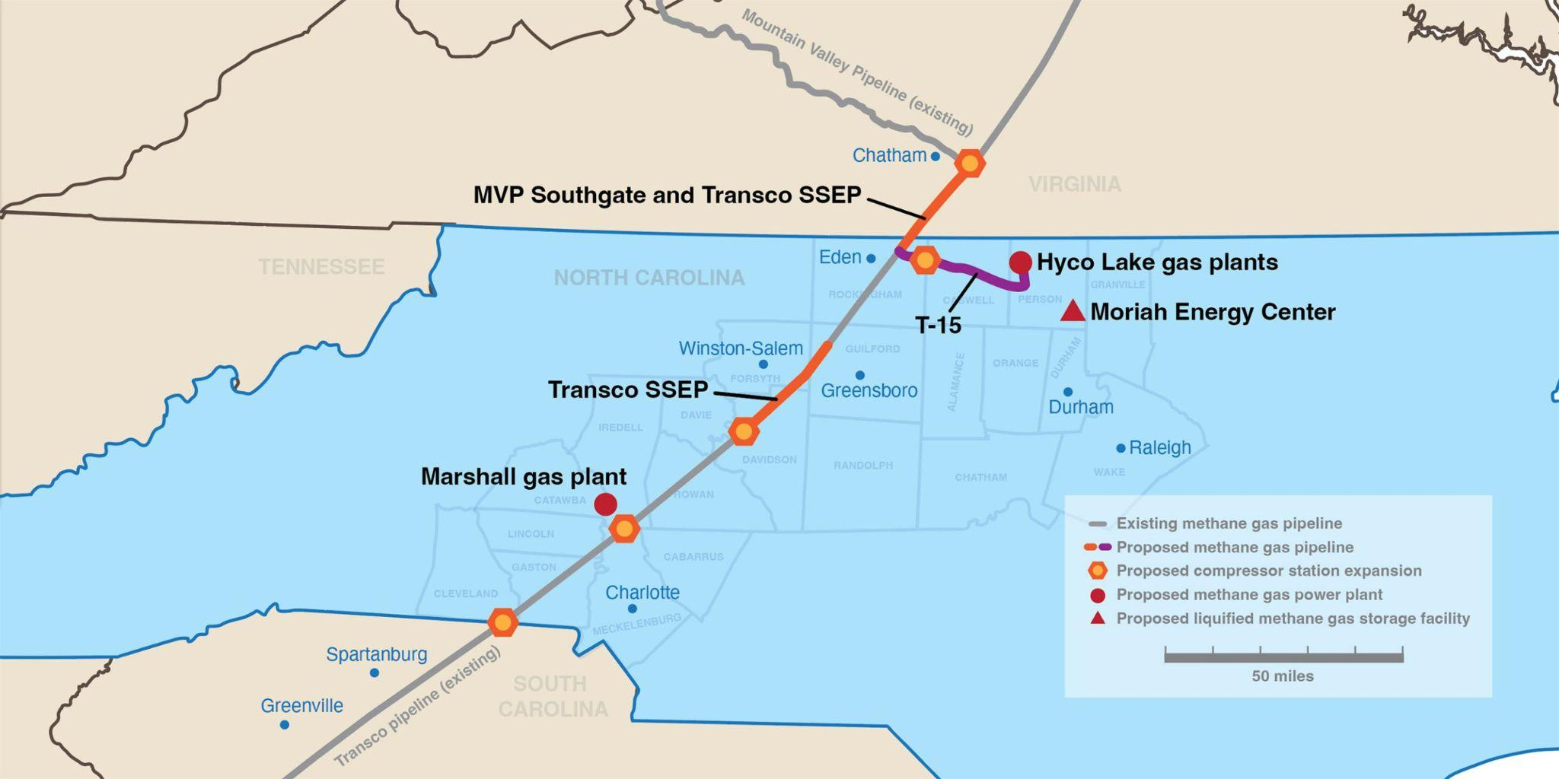

Figure 2: A Comprehensive Overview of the North Carolina Gas Buildout. [38]

As illustrated above, Person County is projected to serve as a hub for transportation and combustion of methane gas, with three potential projects located within the boundaries of the county. If the T-15 pipeline, the gas plant converted from a coal plant, and the Moriah Energy Center are all approved, this will undoubtedly place a significant multi-faceted pollution burden on a community that has already been exposed to coal pollution for decades.

It is also important to highlight the potential economic dependency influencing the attitudes of these communities. As one of the largest employers in the county, Duke Energy is a significant contributor to the tax base with an economic impact of around $7 million annually.[39] Almost 20% of the county’s tax revenue comes from Duke Energy, meaning there is significant reliance on these fossil fuel projects. It is understandable that a denial of this permit would cause community concerns, as a failure to convert this coal plant to another environmentally friendly alternative could result in lost jobs and revenue for a rural area. However, we as environmental and social justice organizations would want these permits denied in favor of renewable projects that either keep or increase the number of potential jobs available and stabilize the tax base for the development and prosperity of Person County.

Siting a utility scale solar and storage project on the site currently occupied by the Roxboro Steam Station would lower air emissions in the area and begin to alleviate legacy pollution borne by these communities. A solar facility would use existing transmission infrastructure in the area, therefore significantly reducing the amount of time the site would need to interconnect to the grid. Battery storage as a component of the site would assist with stabilization and provide resilience in the event of an extreme storm. A model from Xcel Energy has shown that a solar plus battery storage facility at Roxboro would initially cost $1 billion; however, just the first of two methane plants at Roxboro are slated to cost $2 billion even without pipeline costs and ongoing customer-shouldered fuel costs.[40] This plant would also allow Duke to take advantage of IRA funding like the Energy Infrastructure Reinvestment program (EIR), reducing taxpayer costs even further. This site would also maintain the tax revenue base Person County communities depend on.

Person County is already a hub for many of the cumulative impacts of fossil fuel infrastructure. Adding more gas plants imperils this already vulnerable community affected by multiple sources of air pollution and suffering from a spate of air pollution-related health impacts. Instead, this same site can be reimagined into a powerhouse solar and battery storage facility that minimizes environmental and economic risk, while protecting the current tax base.

**Conclusion**

We believe that through a denial of this permit modification, Duke Energy would be forced to go back to the drawing board and truly implement an aggressive approach to the legal mandates of House Bill 951 and reduce the pollution burden forced upon the residents of Person County. We ask experts in air quality to understand the material impacts — economic, environmental, and health — of increasing methane-gas related air pollution in our state.

Thank you for your consideration.

Signed,

Meech Carter, *North Carolina League of Conservation Voters*

Sophie Loeb, *Center for Progressive Reform*

Brittany Griffin, *CleanAIRE NC*

Yuqi Sun, Law Student, *Professor Victor Flatt, Case Western Reserve University School of Law*

1. [What makes methane a more potent greenhouse gas than carbon dioxide? | MIT Climate Portal](https://climate.mit.edu/ask-mit/what-makes-methane-more-potent-greenhouse-gas-carbon-dioxide)
2. [Why do we compare methane to carbon dioxide over a 100-year timeframe? Are we underrating the importance of methane emissions? | MIT Climate Portal](https://climate.mit.edu/ask-mit/why-do-we-compare-methane-carbon-dioxide-over-100-year-timeframe-are-we-underrating)
3. [2017 Order Responding to 2016 Petition to Object to Duke Energy Roxboro Permit](https://www.epa.gov/sites/default/files/2017-07/documents/duke_roxboro_response2016_0.pdf)
4. [Air pollution and chronic airway diseases: what should people know and do? - PMC](https://pmc.ncbi.nlm.nih.gov/articles/PMC4740163/); [Arsenic](https://www.who.int/news-room/fact-sheets/detail/arsenic#:~:text=Arsenic%20is%20naturally%20present%20at,increased%20deaths%20in%20young%20adults).
5. <https://starw1.ncuc.gov/ncuc/ViewFile.aspx?Id=cfc6d586-12e4-447f-a552-757d6e73c30e>
6. [42 U.S. Code § 7475 - Preconstruction requirements](https://www.law.cornell.edu/uscode/text/42/7475)
7. [Attainment Status of National Ambient Air Quality Standards | NC DEQ](https://www.deq.nc.gov/about/divisions/air-quality/air-quality-planning/attainment-status-national-ambient-air-quality-standards#:~:text=The%20Clean%20Air%20Act%20defines,of%20an%20independent%20scientific%20panel.)
8. Id.
9. [Prevention of Significant Deterioration Basic Information | US EPA](https://www.epa.gov/nsr/prevention-significant-deterioration-basic-information)
10. [North Carolina Prevention of Significant Deterioration Modeling Guidance](https://www.deq.nc.gov/water-quality/aquifer-protection/afo/permits/mets/nc-psd-modeling-guidance-20200701/download) at 21.
11. Id.
12. Id. at 22
13. [North Carolina Prevention of Significant Deterioration Modeling Guidance](https://www.deq.nc.gov/water-quality/aquifer-protection/afo/permits/mets/nc-psd-modeling-guidance-20200701/download)
14. [North Carolina Prevention of Significant Deterioration Modeling Guidance](https://www.deq.nc.gov/water-quality/aquifer-protection/afo/permits/mets/nc-psd-modeling-guidance-20200701/download) at 18.
15. [Experts Expose Risks of Duke’s Proposal for Costly, Polluting Roxboro Gas Plant - Southern Environmental Law Center](https://www.southernenvironment.org/press-release/experts-expose-risks-of-dukes-proposal-for-costly-polluting-roxboro-gas-plant/)
16. [1 Duke Energy Comments on the Environmental Protection Agency’s Request for Public Input on Emission Guidelines for Greenhouse](https://downloads.regulations.gov/EPA-HQ-OAR-2024-0135-0060/attachment_1.pdf)
17. <https://www.msn.com/en-us/news/news/content/ar-AA1somks>
18. [Experts Expose Risks of Duke’s Proposal for Costly, Polluting Roxboro Gas Plant - Southern Environmental Law Center](https://www.southernenvironment.org/press-release/experts-expose-risks-of-dukes-proposal-for-costly-polluting-roxboro-gas-plant/)
19. <https://starw1.ncuc.gov/NCUC/ViewFile.aspx?Id=6ff40c03-e54f-4efc-a988-73916abf08f9>
20. <https://starw1.ncuc.gov/ncuc/ViewFile.aspx?Id=cfc6d586-12e4-447f-a552-757d6e73c30e>
21. [How Sandy Norris was able to lower her energy usage, save money](https://illumination.duke-energy.com/articles/how-sandy-norris-was-able-to-lower-her-energy-usage-save-money)
22. [North Carolina Climate Plan Must Include Clean, Affordable Energy for Underserved Residents - Center for Progressive Reform](https://progressivereform.org/cpr-blog/north-carolina-climate-plan-must-include-clean-affordable-energy-underserved-residents/)
23. [Issue Brief: The Role of Fuel Costs in Duke Energy’s North Carolina’s Retail Rates From 2017 Through March 2024](https://www.edf.org/sites/default/files/documents/Issue_Brief_Narrative_4_22_24.pdf)
24. [Duke Energy unveils plans for new natural gas plant in Catawba County • NC Newsline](https://ncnewsline.com/2024/03/18/duke-energy-unveils-plans-for-new-natural-gas-plant-in-catawba-county/)
25. [Global estimation of mortality, disability-adjusted life years and welfare cost from exposure to ambient air pollution - PubMed](https://pubmed.ncbi.nlm.nih.gov/32721745/)
26. [Global Health Estimates: Life expectancy and leading causes of death and disability](https://www.who.int/data/gho/data/themes/mortality-and-global-health-estimates)
27. [CDC SVI Documentation 2022 | Place and Health | ATSDR](https://www.atsdr.cdc.gov/placeandhealth/svi/documentation/SVI_documentation_2022.html)
28. [Air Pollution and Asthma | AAFA.org](https://aafa.org/asthma/asthma-triggers-causes/air-pollution-smog-asthma/)
29. <https://experience.arcgis.com/experience/4c9561f7a1a7415d86201a785753e56f/page/Page/?views=ENVIRONMENTAL#data_s=id%3Awidget_8_output_config_0%3A0%2Cid%3AdataSource_2-1900c749e36-layer-58-1900c74b18f-layer-67%3A56884>
30. Semieniuk, G., Holden, P.B., Mercure, JF. et al. Stranded fossil-fuel assets translate to major losses for investors in advanced economies. Nat. Clim. Chang. 12, 532–538 (2022). [Stranded fossil-fuel assets translate to major losses for investors in advanced economies | Nature Climate Change](https://doi.org/10.1038/s41558-022-01356-y)
31. [Five Things to Know as NC Plans its Energy Future](https://energync.org/five-things-to-know-as-nc-plans-its-energy-future/)
32. Carbon plan graph, <https://starw1.ncuc.gov/ncuc/ViewFile.aspx?Id=cfc6d586-12e4-447f-a552-757d6e73c30e>
33. [Rising to the Challenge: How State Public Utilities Commissions Can Use the Inflation Reduction Act to Advance Clean Energy - Center for Progressive Reform](https://progressivereform.org/publications/rising-to-the-challenge/)
34. [Rising to the Challenge: How State Public Utilities Commissions Can Use the Inflation Reduction Act to Advance Clean Energy - Center for Progressive Reform](https://progressivereform.org/publications/rising-to-the-challenge/)
35. 42 U.S.C. § 7410(a)(2)(D)(i)(I).
36. [Atmospheric Dispersion and Pollution Transport - Air Quality Portal](https://airquality.climate.ncsu.edu/2021/06/06/atmospheric-dispersion-and-pollution-transport/)

    [Geography | North Carolina Climate](https://learn.weatherstem.com/modules/learn/lessons/140/08.html)

    [Wind Rose Tool - Air Quality Portal](https://airquality.climate.ncsu.edu/wind/)

    [U.S. Wind Climatology | National Centers for Environmental Information (NCEI)](https://www.ncei.noaa.gov/access/monitoring/wind/)
37. U.S. Environmental Protection Agency, *States That Are Affected by the Cross-State Air Pollution Rule (CSAPR)*, <https://www.epa.gov/Cross-State-Air-Pollution/states-are-affected-cross-state-air-pollution-rule-csapr> (last accessed Nov. 8, 2024).
38. [A proposed gas buildout in North Carolina puts our communities and land at risk](https://appvoices.org/pipelines/nc-gas-buildout/)
39. [Advancing the future of energy with Person County, NC](https://illumination.duke-energy.com/articles/advancing-the-future-of-energy-with-person-county-nc)
40. [Person County deserves a better deal from Duke - SACE | Southern Alliance for Clean Energy](https://www.cleanenergy.org/blog/person-county-deserves-a-better-deal-from-duke/)